

INTEGRATED SCIENCE

STAGE 2 DRAFT SAMPLE EXAMINATION

Section 7 of the New WACE Manual: General Information (Revised) outlines the policy on WACE examinations.

Further information about the WACE Examinations policy can be accessed from the Curriculum Council website at http://www.curriculum.wa.edu.au/.

The purpose for providing a sample examination is to provide teachers with an example of how the course will be examined. Further finetuning will be made to this sample in 2008 by the examination panel following consultation with teachers, measurement specialists and advice from the Assessment, Review and Moderation (ARM) panel.

2008/23332



Western Australian Certificate of Education, Draft Sample External Examination
Question/Answer Booklet

INTEGRATED SCIENCE
Please place your student identification label in this box
WRITTEN PAPER
STAGE 2

Student Number: In figures

In words

Time allowed for this paper
Reading time before commencing work: 10 minutes
Working time for paper: 3 hours

Materials required/recommended for this paper
To be provided by the supervisor
Question/answer booklet
Integrated Science: Formulae and Data Sheet (inside front cover of this Question/Answer Booklet)
Separate multiple-choice answer sheet

To be provided by the candidate
Standard items: Pens, pencils, eraser or correction fluid, ruler, highlighter
Special items: Non-programmable scientific calculator, drawing instruments and templates.

Important note to candidates
No other items may be taken into the examination room. It is your responsibility to ensure that you do not have any unauthorised notes or other items of a non-personal nature in the examination room. If you have any unauthorised material with you, hand it to the supervisor before reading any further.

Structure of this paper

Section | Suggested working time | Number of questions available | Number of questions to be attempted | Marks
Section One  Multiple-choice | 30 minutes | 20 | 20 | 40 (20%)
Section Two  Short answer | 110 minutes | 6 | 6 | 120 (60%)
Section Three  Extended answer | 40 minutes | 2 | 2 | 40 (20%)
Total marks |  |  |  | 200

Instructions to candidates
- The rules for the conduct of the Western Australian external examinations are detailed in the TEE/WACE Handbook. Sitting this examination implies that you agree to abide by these rules.

SECTION ONE: MULTIPLE-CHOICE [40 marks]

There are TWENTY (20) questions in this section. Attempt ALL questions.

Mark your answers to questions 1–20 on the SEPARATE MULTIPLE-CHOICE ANSWER SHEET using a 2B, B or HB pencil.

Suggested working time: 30 minutes

- The function of water in biological systems is due to

  - its unique physical and chemical properties.
  - only its physical properties.
  - only its chemical properties.
  - neither its physical and chemical properties.

- Why are control groups used in experiments?

  - To compare with the experimental group.
  - To increase the sample size.
  - To ensure that the experiment can be replicated.
  - To test the experimental hypothesis.

- Why are microscopic membrane filters useful for water purification?

  - They can kill bacteria.
  - They adjust the pH of the water to 7.
  - They are composed of biodegradable polymers.
  - They can remove very small particles from the water.
[From: Board of Studies New South Wales, 2006]

Use the following information to answer the next two questions.

Analysis of water from a lake adjacent to a power plant

Water Quality Parameter | Reading
pH | 5.00
Biological Oxygen Demand (BOD) | 25 :g/mL
Lead (Pb) | 100 :g/mL
Temperature at the bottom of the lake | 10°C

- The water quality parameter that indicates the presence of a significant amount of living matter is

  - low pH.
  - high BOD.
  - high temperature.
  - high concentration of heavy metals.
[From: Alberta Learning, Reproduced with the permission of the Minister of Education, Province of Alberta, Canada, 2007]

- Increasing the temperature of the water in the lake

  - increases the density.
  - increases the solubility of ions.
  - increases the solubility of oxygen.
  - all of the above.

Question 6 relates to the following diagram of osmoregulation in a freshwater fish.

For copyright reasons this diagram cannot be reproduced in the online version of this document.

[Adapted from: Campbell et al., 2003]

- Which of the following statements regarding the diagram is true?

  - Arrow A indicates osmotic water loss across the gills.
  - Arrow B indicates uptake of salty water.
  - Arrow C indicates uptake of salt across the gills.
  - Arrow D indicates excretion of highly concentrated urine.

- The following concentrations of a toxic heavy metal were measured in organisms living in a local and confined area.

Organism | Toxin concentration (ppm)
W | 8.050
X | 25.000
Y | 2.400
Z | 0.009

The organisms studied were:

Carnivorous fish Algae Herbivorous fish Freshwater crocodiles

In which of the following is the organism most likely correctly matched with the measured concentration of heavy metal?

 | W | X | Y | Z
(A) | Algae | Herbivorous fish | Carnivorous fish | Freshwater crocodiles
(B) | Freshwater crocodiles | Carnivorous fish | Herbivorous fish | Algae
(C) | Algae | Carnivorous fish | Freshwater crocodiles | Herbivorous fish
(D) | Carnivorous fish | Freshwater crocodiles | Herbivorous fish | Algae
[Adapted from: Australian Science Innovations, 2001]

- Grease deposits on cookware can be removed by using a suitable solvent. The solvent could be

  - water because it is polar and is the 'universal solvent'.
  - hot water because solubility increases with temperature.
  - a petroleum based solvent because it has similar bonds to the grease.
  - a solvent with hydrogen bonds as these are the most soluble.

- After the first hot day of summer, you will find the water in a swimming pool extremely cold because

  - the water/air boundary does not absorb heat quickly.
  - the water/air boundary allows the heat to escape easily.
  - the specific heat capacity of water is high.
  - the specific heat capacity of water is low.

- Aquatic insects can be observed to walk on water due to

- cohesive forces acting between the water molecules.
- adhesive forces acting between the water molecules.
- adhesive forces acting between the water molecules and the insect.
- cohesive forces acting between the water molecules and the insect.

Question 11 relates to the following graph.

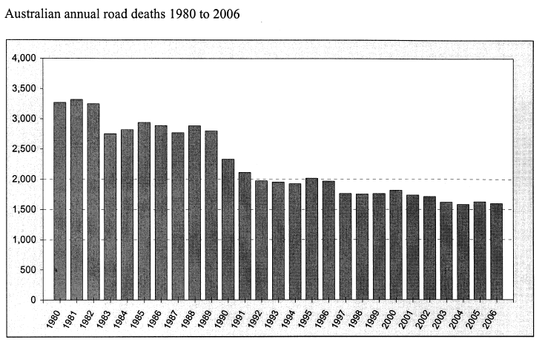

[From: Australian Transport Safety Bureau, 2007]

- The graph shows a downward trend in road accident fatalities. This can most likely be attributed to

- the high cost of fuel, which has reduced the use of vehicles.
- the National Road Safety strategy introduced in 1992.
- the introduction of the compulsory use of seatbelts.
- a combination of factors including road design, driver safety campaigns and improved car design.

- Research indicates that young drivers face a significantly higher risk of being seriously injured than other drivers. The most likely contributing factor to this greater risk is

- drinking and driving.
- not wearing a seat belt.
- driving more powerful cars.
- less developed driving skills, resulting from having little on-road experience.

- A car is travelling at a constant speed of 18m s⁻¹ when the driver sees an obstacle on the road ahead and needs to brake. If his reaction time is 1.5 seconds and the car decelerates at a rate of 5ms⁻², how far will the car travel before the driver applies the brakes?

- 7.5m
- 27m
- 32.4m
- 59.4m

- An egg dropped in an egg carton might survive cracking open. A motorcyclist wearing a helmet who fell off his bike and hit his head on the curb may similarly avoid serious injury. The reason for this would be

- the helmet increases the time over which the impact lasts
- the helmet prevents an impact between his head and the kerb
- the helmet decreases the momentum of impact
- the helmet decreases the time of the impact.

- Random roadside drug testing involves a

- breath test.
- saliva test.
- urine test.
- blood test .

- A standard drink contains

- 5 grams of alcohol.
- 10 grams of alcohol.
- 15 grams of alcohol.
- 20 grams of alcohol.

- In a test to determine the effect of a pain-killing drug on reflex activity, 20 people were given increasing amounts of the drug at two hour intervals. Their reflex activity was measured shortly after each dose. The results are shown in the following graph.

Average
Reflex
Time

Dosage

Which of the following implies the most serious defect in the design of this experiment?

- It is assumed that all people normally have the same reflex time.
- Different groups of twenty people should have been used for each dose.
- The experiment should have been repeated several times to see whether consistent results were obtained.
- Higher doses should have been used to see whether greater effects were produced.

- Roger had his hearing examined before working in a factory. His hearing was re-examined one year later. The results of these examinations are shown on the graph below.

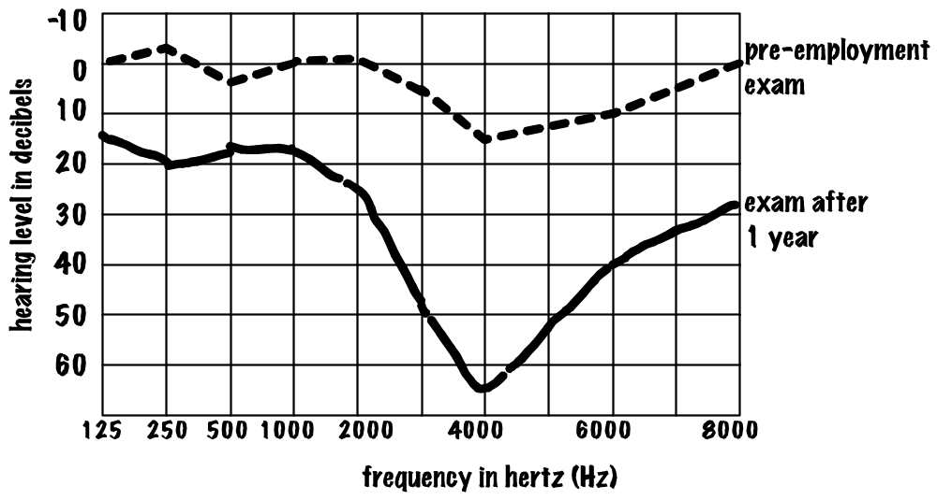
[Diagram from: R. Meagher]

Which of the following statements best matches the results of the exams?

- The degree of hearing loss recorded is to be expected with aging.
- Normal conversation is around 2000Hz, so Roger will notice very little hearing loss.
- Machines in his factory are exposing him to high levels of noise across all frequencies, but particularly at 4000Hz.
- Machines in his factory are exposing him to high levels of noise, only at 4000Hz.

- The property of a sound wave that is closely related to its pitch is
- loudness.
- speed.
- frequency.
- amplitude.

- Which of the following is true?

- Sound waves have different speeds in vacuum for different frequencies.
- Sound waves are transverse waves.
- Sound waves require a medium for propagation.
- Longer wavelength sounds are lower than shorter wavelength sounds.

END OF SECTION ONE

THIS PAGE HAS BEEN LEFT BLANK INTENTIONALLY

SECTION TWO: SHORT ANSWERS [120 marks]

There are SIX (6) questions in this section. Attempt ALL questions.

Answer all questions in this section in the spaces provided.

Suggested working time: 110 minutes

Question 1
The nervous system allows a driver to be aware of his or her surroundings and react to any changes that are occurring.

[4 marks]

For copyright reasons this diagram cannot be reproduced in the online version of this document.

[Diagram adapted from: Martini, 2001]

- Refer to the diagram above to identify the parts labelled.

P

Q

R

U

- Describe how messages are transmitted

  - along the neuron.
[2 marks]

  - from the end of one neuron, across the synapse, to the beginning of the next neuron.
[2 marks]

The reaction distance can be calculated if the original speed of the car and the reaction time of the driver are known.

- List three factors that can affect the reaction time of a driver.
[3 marks]
1.
2.
3.

The following table shows the approximate reaction distances, braking distances and stopping distances at various speeds for a car in good condition on a dry bitumen road.

A reaction time of 1 second has been assumed.

Speed (km h⁻¹) | Reaction distance (m) | Braking distance (m) | Stopping distance (m)
30 | 8 | 5 | 13
60 | 16 | 20 | 36
90 | 24 | 45 | 69
120 | 32 | 80 | 112

- Use the above information to draw graphs in the grid below to show how reaction distance and braking distance change as speed increases.
[4 marks]

- Describe the difference between reaction distance and braking distance from the information on your graph.
[2 marks]

- Describe two measures being implemented to decrease the risk of a crash due to speeding.
[2 marks]

THIS PAGE HAS BEEN LEFT BLANK INTENTIONALLY

Question 2
A measure that assists audio engineers when determining a design of a room is the Noise Reduction Coefficient (NRC). When sound energy hits a boundary, some of it is reflected, some is absorbed, and some is transmitted through the boundary. The percentage of sound reflection, absorption and transmission depends on the material. The amount of energy absorbed can be expressed as a fraction of the total energy (E). For example 3% absorption would be 0.03 E. This number is called the absorption coefficient. In general, soft porous materials absorb sound better than hard materials.

A student wanted to compare the noise reduction offered by a number of materials and decided to perform an experiment. He had the equipment illustrated below:
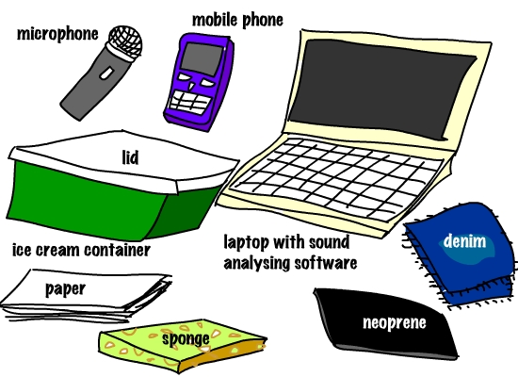
[Diagram from: R. Meagher]

He connected the microphone to his laptop. He used software to analyse the sounds picked up by the microphone, and register the sound level in decibels. He measured the noise reduction qualities of the materials that he had. He placed his mobile phone in an ice-cream container made it play a musical ring tone. He then measured the sound with his microphone held just above the unsealed ice-cream container. His microphone sent the signal to his computer, which recorded the sound level. He then repeated the test by covering his phone with each of the materials and recorded the sound level at the microphone. His results are listed below:

I. ring tone with no lid 60–70dB
II. ring tone with two layers of denim 58–68dB
III. ring tone with 3cm of sponge rubber 56–66dB
IV. ring tone with 0.5cm thick neoprene (i.e. wet suit material) 53–60dB
V. ring tone with 50 sheets of paper 54–64dB
VI. ring tone with the ice-cream container’s lid 58–68dB

- Which of the tests was performed as a control? Explain.
[2 marks]

- Why did the results in each test produce a range of sound levels? Suggest how the experiment could have been modified to record only one sound level for each test?
[2 marks]

- What other modifications could be made to the experiment to ensure that the data collected are more reliable and valid?
[4 marks]

Materials exhibit different absorption characteristics at different frequencies. For instance, wallpapered plaster has an absorption coefficient of 0.03 at the 250 Hz octave band, 0.04 at the 500 Hz octave band, 0.05 at the 1000 Hz octave band, and 0.07 at the 2000 Hz octave band.

- Use this information to explain the data obtained for neoprene.
[2 marks]

- Describe the changes in procedure for a subsequent experiment that could be performed to investigate how materials affect the transmissions of different frequency sounds.
[3 marks]

- Use the concepts of reflection and absorption of sound to explain the following observations. ‘When entering a large, empty gymnasium many echoes are heard. However when the same gymnasium is full of students, during an assembly, echoes are not so obvious.’
[4 marks]

THIS SPACE HAS BEEN LEFT BLANK INTENTIONALLY

- The diagram below shows two floor plans for concert halls. Which hall, A or B, would be the best to listen to music in, and why?
[3 marks]

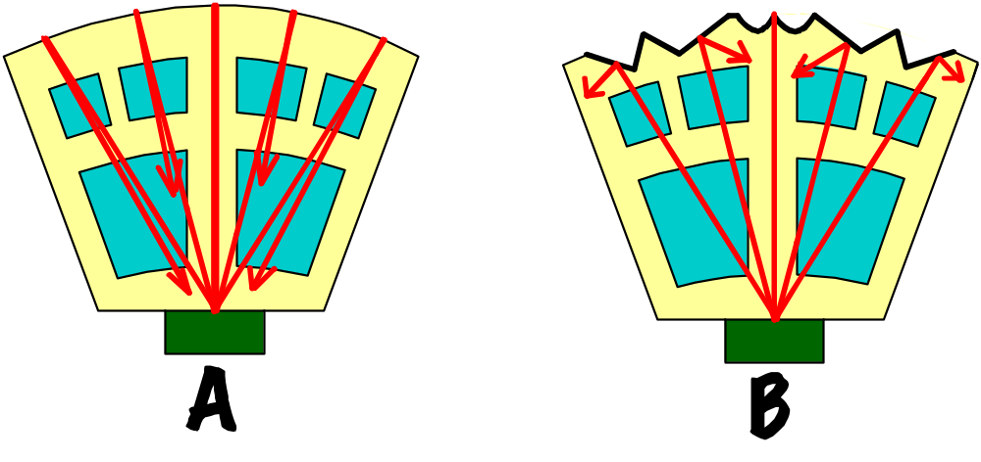
[Diagram from: R. Meagher]

THIS SPACE HAS BEEN LEFT BLANK INTENTIONALLY
Question 3

Figure 1: diagram of the human ear

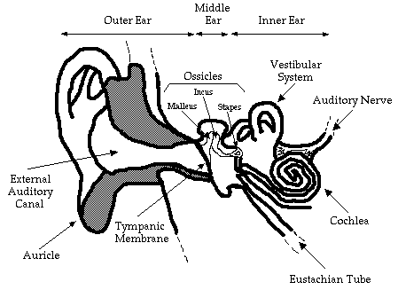
[From: Esse & Thibodeau, n.d.]

- Describe the path of the sound wave from the outer ear to the auditory nerve using the information in the diagram and your knowledge of how sound travels.
[6 marks]

The sketch below shows a map of the compressions and rarefactions of the air in a tube as a sound wave travels away from the tuning fork down the tube. The relative density of the dots represents the relative pressure of the air molecules.

Figure 2: diagram of a vibrating tuning fork

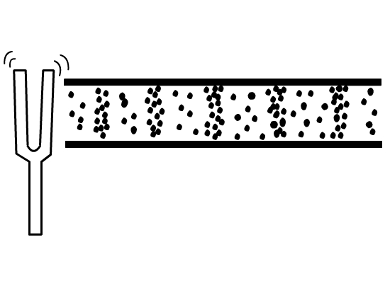
1cm234567891011
[Diagram from: R. Meagher]

- Determine the average wavelength of the sound waves represented in the diagram above by measuring these on the diagram using the scale provided.
[2 marks]

- The AFL installs a 10,000 hertz (Hz) siren in a football stadium. When testing the siren, they decide to vary the sound. They determine that when the amplitude is doubled the loudness of the siren increases, but when the frequency is doubled the sound heard seems quieter and some people can’t hear it at all. Explain both of these observations.
[2 marks]
Amplitude doubled:

Frequency doubled:

- The velocity of the sound wave coming from a source is 346 m s⁻¹ and its frequency is 2,000 Hz. Calculate the wavelength of this source. Show your working.
[3 marks]

- Complete the following table by describing one difference between conductive deafness and nerve deafness and how each can be treated.
[4 marks]

 | Conductive deafness | Nerve deafness
Cause in relation to how the ear works
Treatment

- Explain how hearing loss can be caused by continual exposure to loud noises such as when working in a noisy industrial site.
[3 marks]

THIS PAGE HAS BEEN LEFT BLANK INTENTIONALLY

Question 4
Sewage refers to water that has been used by household or industry. It includes toilet wastes and all household water, but excludes storm water, which is usually diverted directly into waterways. Sewage can undergo three levels of processing or purification once it reaches a sewage plant. Primary and secondary treatment is shown in the diagram below.

Figure 3: Flow diagram representing a sewage plant in Perth

8. Reverse osmosis

Liquid primary effluent
6. Aerobic digestion

7. Final settling (gravity) Final skim

Raw sewage
2. Sedimentation & skim (gravity)

1. Barscreen
3. Slurry digestor - anaerobic decomposition

4. Dewatering
5. Soil conditioning
Liquid secondary effluent

9. Sand filter and chlorinate

10. Pumped to ocean

Solids

- Identify and describe the steps in the primary treatment of sewage.
[4 marks]

- Explain the differences between the biological processes and products occurring in the aerobic and the anaerobic digestion tanks.
[4 marks]

- Explain why it is important to add a solution of iron (II) chloride to the liquid secondary effluent containing phosphate ions, to form an insoluble compound of iron phosphate.
[2 marks]

- The liquid secondary effluent from tank 9 is not potable (not suitable for drinking). Explain why this process does not produce potable water.
[4 marks]

- The water from tank 9 cannot be discharged into the river. Make two suggestions where this water could be used.
[2 marks]
1.

2.

- One of the current considerations of the Water Corporation of WA is to reuse 20% of its treated water by 2012. Explain why the treatment process used, ensures the health and safety of the treated wastewater for human consumption.
[4 marks]

THIS PAGE HAS BEEN LEFT BLANK INTENTIONALLY
Question 5
A large area of the Swan-Canning river system was affected by a toxic blue-green algal bloom in February 2000, causing areas to be closed to recreational activities. The cause of the unusual and massive bloom in the Swan and lower Canning rivers can be largely explained by two unseasonably large rain events that occurred in January 2000. Much of this rainfall occurred over the Avon River catchment in the agricultural area to the south-east of Perth, with enough water entering the Swan-Canning estuary to fill it five and a half times over.
[Adapted from: Swan River Trust, 2000]

Table 1: Measurements taken at site X in the
Swan-Canning River system in January, February and April 2000

Date | Chlorophyll a  (µg/L) | Surface  or  bottom (depth (m)) | Salinity *(ppt) | Temperature (ºC) | Dissolved Oxygen (mg/L) | Total Nitrogen | Total  Phosphorus
17 Jan 2000 | 49 | surface (0.5) | 6.15 | 10.85 | 7.77 | 1.9 | 0.15
17 Jan 2000 | 49 | bottom (4.5) | 19.64 | 31.52 | 0.18 | 0.94 | 0.27
21 Feb 2000 | 75 | surface (0.5) | 4.98 | 26.82 | 8.23 | 1.5 | 0.08
21 Feb 2000 | 75 | bottom (4.5) | 4.97 | 24.67 | 5.07 | 1.5 | 0.09
17 April 2000 | 34 | surface (0.5) | 20.7 | 20.78 | 10.06 | 0.7 | 0.12
17 April 2000 | 34 | bottom (4.5) | 23.3 | 21.08 | 0.011 | 0.9 | 0.12
[Data from: Swan River Trust]
* ppt - parts per thousand

- Graph the salinity at the surface and the bottom in the period from January to April on the grid provided below.
[4 marks]

- Explain why there is a difference between the salinity at the surface and the bottom of the river on the 17 January.
[2 marks]

- Explain why the salinity readings have changed from:

  - 17 January to 21 February
[2 marks]

  - 21 February to 17 April
[3 marks]

The Swan River has hundreds of naturally occurring microscopic algae species (known collectively as phytoplankton) most of which are not harmful to humans or animals. The river's algae go through typical bloom cycles. Different algae prefer different conditions so a number of factors will determine which algae will be most successful and bloom at any particular time.

Microcystis aeruginosa is a blue-green algae that does particularly well in freshwater and low salinity conditions. Microcystis floats in the surface waters and thus receives strong sunlight.
[Adapted from: Swan River Trust, 2000]

- Explain the importance of algae to the river ecosystem.
[2 marks]

Use information from the table and your knowledge of plant requirements for growth to answer the following questions.

- What two factors changed during the summer to cause the algal bloom during February 2000.
[2 marks]
1.

2.

- Unusual rain events occurred during summer as indicated. Name two other factors that would have contributed to the algal growth?
[2 marks]
1.

2.

- Explain why a sampling program was established to monitor the growth, toxicity and location of the algal bloom.
[2 marks]

- Taking into account the requirements of algae, suggest one method that could be used to control the bloom.
[1 mark]

THIS PAGE HAS BEEN LEFT BLANK INTENTIONALLY

Question 6
The Perth Seawater Desalination plant, located at Kwinana, 40 kilometres south of Perth is a key part of the Water Corporation's Security through Diversity strategy to secure the long-term water supply for WA and is located at Kwinana. It started supplying water into the Integrated Water Supply Scheme in November 2006. The plant uses the reverse osmosis desalination process to remove dissolved salts from seawater to obtain fresh water. By harvesting water from the ocean, the State has acquired an abundant source that is not dependent on rainfall - an important factor in the face of a variable climate. At full capacity it provides 17 per cent of Perth's water needs. On average, the plant produces up to 130 million litres of drinking water per day, or 45 gigalitres per year. (Water Corporation)

Figure 4: The desalination process

water forced through membrane at high pressure

seawater intake

return to sea
pre-treatment
filter seawater

post-treatment with lime, chlorine and fluoride

storage

delivery to integrated Water Supply System

return to sea

filter backwash
seawater concentrate
[Adapted from: Water Corporation, 2005]

- Explain why the Environmental Protection Authority monitors dissolved oxygen levels, temperature and conductivity levels in Cockburn Sound.
[3 marks]

- Approximately 1.6 million people supplied by the Integrated Water Supply Scheme. Calculate the total amount of water consumed per person per day.
[4 marks]

- Describe, with the aid of a diagram, the process of reverse osmosis.
[5 marks]

- (i) Define desalination
[1 mark]

(ii) explain why the Perth Seawater Desalination plant has been built in preference to building new dams or increasing use of groundwater.
[3 marks]

A survey was undertaken in 2004 of the site proposed for the desalination plant. It found that nearly two thirds of the plant species were weeds, but they did play an important role in stabilising the soil and protecting the area from wind and wave erosion.

- Give two reasons why such a study should be carried out before a desalination plant is built?
[2 marks]
1.

2.

- Explain two advantages of revegetating the site with native species, such as wattle and spinifex.
[2 marks]
1.

2.

END OF SECTION TWO

SECTION THREE: EXTENDED ANSWER [40 marks]

There are TWO (2) questions in this section. Answer both questions.

Suggested working time: 40 minutes

Question 7

- Using your scientific knowledge of total stopping distance, list and explain five factors that contribute to car accidents:
[10 marks]
Factor | Explanation
1.
2.
3.
4.
5.

- Use of seat belts by occupants of a vehicle and crumple zones in the design of a vehicle have been proven to reduce death and serious injury. Use your knowledge of Newton's Laws of Motion to explain how each of these reduce the impact in an accident.
[10 marks]

Question 8
The Western Australian environment, economy, community health and lifestyle all depend upon the availability of good quality freshwater. As the State's population has grown so has the demand for water, bringing with it the responsibility to manage this resource sustainably. This requires more strategic ways for water resources to be developed, protected, used and reused.

Perth householders use 18% of the total water resources for the State. Water consumption by householders is shown in the table below. The target adopted in the State water strategy is less than 155 kL per person in a given year.

Table 2: Annual household water consumption per capita for Perth.

Year | Water consumption kL/person/year
1999-2000 | 175
2000-2001 | 187
2001-2002 | 153
2002-2003 | 150
2003-2004 | 155
2004-2005 | 154
2005-2006 | 151
2006-2007 | 153

The largest water users are the irrigated agricultural (40%) and mining (24%) sectors. Other users include industry, parks and gardens, services and water for stock.
[Adapted from: Environmental Protection Authority, 2006]

Discuss ways in which water can be conserved and managed in agriculture, households and by Shire councils. Consider the following in your answer.
- reasons for decreased consumption by households since 2001
- measures that can be taken by agriculture to reduce water consumption
- implications of changing patterns of rainfall in W.A.
[20 marks]

ACKNOWLEDGEMENTS

SECTION ONE: MULTIPLE-CHOICE

Question 3 Board of Studies New South Wales. (2006). Chemistry: 2006 Higher School Certificate Examination (p. 7). Retrieved October, 2007, from http://www.boardofstudies.nsw.edu.au/hsc_exams/hsc2006exams/pdf_doc/chemistry_06.pdf.

Question 4 Alberta Learning. (2001). Science 30: Grade 12 Diploma Examination: June 2001 (p. 14). Retrieved October, 2007, from http://www.education.gov.ab.ca/k%5F12/testing/diploma/examskeys/2001/sci30_june01_de.pdf.

Question 6 Diagram adapted from: Campbell, N.A., Reece, J.B., Mitchell, L.G., & Taylor, M.R. (2003). Biology: Concepts and connections. San Francisco: Benjamin Cummings, p.507.

Question 7 Adapted from: Australian Science Innovations. (2001). Biology: 2001 national qualifying examination (p. 8). Retrieved October, 2007, from http://www.aso.edu.au/www/docs/2001%20Biology%20NQE%20Questions.pdf.

Question 11 Diagram from: Australian Transport Safety Bureau (2007). Road Deaths Australia, 2006 Statistical Summary (p. 2). Retrieved December, 2007, from http://www.atsb.gov.au/publications/2007/pdf/mrf_2006.pdf

Question 18 Diagram by kind permission Richard Meagher. http://www.meaghersphysics.podomatic.com

SECTION TWO: SHORT ANSWERS

Question 1 Diagram from: Martini, F.H., Ober, W.C., Garrison, C.W., Welch, K., & Hutchings, R.T. (2001). Fundamentals of anatomy and physiology (5th ed.). Upper Saddle River, NJ: Prentice Hall, p. 423.

Question 2 Diagram by kind permission Richard Meagher. http://www.meaghersphysics.podomatic.com

Question 3 Diagram from: Esse, S., & Thibodeau, L. (n.d.). The ear. Retrieved October, 2007, from University of Texas at Dallas website: http://www.utdallas.edu/~thib/rehabinfo/te.htm.

Question 3b Diagram by kind permission Richard Meagher. http://www.meaghersphysics.podomatic.com

Question 5 Text adapted from: Swan River Trust. (2000, September). ‘Summer surprise’: The Swan River blue-green algal bloom: February 2000. River Science, 2, pp. 1, 3, 4. Retrieved October, 2007, from http://portal.environment.wa.gov.au/pls/portal/docs/PAGE/ADMIN_SRT/SHEETS/RIVERSCIENCE02.PDF.

Question 6 Diagram adapted from: Water Corporation. (2005). The Perth seawater desalination plant: What is desalination? Retrieved October, 2007, from http://www.watercorporation.com.au/_files/Desalination_what.pdf.

SECTION THREE: APPLICATION

Question 8 Adapted from: Environmental Protection Authority. (2006). State of the environment report: Western Australia draft 2006. Perth: Author, pp. 324–325.
Published by the Curriculum Council of Western Australia
27 Walters Drive
OSBORNE PARK WA 6017

